华东师范大学软件学院实验报告

实验课程：操作系统实践 | 年级：2013级 | 实验成绩：
实验名称：Pintos Prject 2(User Programs in Pintos) | 姓名：杨文韬
实验编号：No.3 | 学号：10132510243 | 实验日期：15-05-25
指导教师：陈闻杰 | 组号： | 实验时间：2学时

一、 设计文档
+------------------+
|PROJECT 2:USERPROG|
|DESIGN DOCUMENT |
| |
+------------------+
---- GROUP ----
杨文韬<854528105@qq.com>
---- PRELIMINARIES ----
Implementation
>> If you have any preliminary comments on your submission, notes for
>> the TAs, or extra credit, please give them here.

>> Please cite any offline or online sources you consulted while
>> preparing your submission, other than the Pintos documentation,
>> course text, and lecture notes.
I watched the Yan Wen's teaching video and his codes .I also look for the information about pintos from the Internet and senior students.

JOIN
====
---- DATA STRUCTURES ----
>> Copy here the declaration of each new or changed ‘struct’ or ‘struct’
>> member, global or static variable, ‘typedef’, or enumeration.
>> Identify the purpose of each in 25 words or less.

在结构体threads中添加成员
struct thread
{
/* Owned by thread.c. */
tid_t tid; /* Thread identifier. */
enum thread_status status; /* Thread state. */
char name[16]; /* Name (for debugging purposes). */
uint8_t *stack; /* Saved stack pointer. */
int priority; /* Priority. */
struct list_elem allelem; /* List element for all threads list. */

/* Shared between thread.c and synch.c. */
struct list_elem elem; /* List element. */

/* My Implementation */
struct alarm alrm; /* alarm object */
int base_priority; /* priority before donate, if nobody donates, then it should be same as priority */
struct list locks; /* the list of locks that it holds */
bool donated; /* whether the thread has been donated priority */
struct lock *blocked; /* by which lock this thread is blocked */

int nice; /* nice value of a thread */
int recent_cpu; /* recent cpu usage */
/* == My Implementation */

#ifdef USERPROG
/* Owned by userprog/process.c. */
uint32_t *pagedir; /* Page directory. */

/* My Implementation */
struct semaphore wait; /* semaphore for process_wait */
int ret_status; /* return status */
struct list files; /* all opened files */
struct file *self; /* the image file on the disk */
struct thread *parent; /* parent process */
/* == My Implementation */
#endif

/* Owned by thread.c. */
unsigned magic; /* Detects stack overflow. */
};

修改echo.c的main函数
int main (int argc, char **argv)
{
int i;
printf("argc=%d",argc);
for (i = 0; i < argc; i++)
{ printf ("argv[%d]=%s ",i, argv[i]);
printf ("\n");}
if(!strcmp(argv[1],”halt”))
halt();
else if (!strcmp(argv[1],”open”))
opne(argv[2]);
else if (!strcmp(argv[1],”exit”))

exit(0);
return EXIT_SUCCESS;
}

/for argument passing. */
Argument Passing也可以理解为参数压栈。
必须先使栈存在，即必须用户线程被创建以及初始化完成。
必须在用户的main函数被执行之前，完成对应的参数的传递。
每一个用户程序的入口函数main()都有两个参数，即int argc和char** argv。且这两个参数需要我们手动的传导用户线程的条用栈中去。

---- ALGORITHMS ----
1.在process.c文件中修改process_execute函数。
2.在process.c文件中修改start_process函数。
3.在process.c文件中修改process_wait函数，实现主线程kernal等待用户线程完成。
4.在process.c文件中修改process_exit函数。

/for system calls.*/
当一个用户程序call一个系统调用的时候，他实际上是对通过其包含的/lib/usr/syscall.h来操作其对应c文件中的syscall()汇编函数，将制定的系统调用号写入到当前用户线程的调用栈顶，同时开启中断，将控制权转给kernel。
我们要把栈中的系统号取出分析，调用相应的系统调用。
实现文件系统的系统调用就是把int fd转化为file结构体变量指针，并通过这个指针调用pintos已经实现了的底层的文件系统调用。

---- ALGORITHMS ----
1.在userprog/syscall.c文件中申明函数。
2.在userprog/syscall.c文件中写syscall_hander函数，实现sys_write，sys_exit，sys_halt，sys_create，sys_open，sys_close，sys_read，sys_exec，sys_wait，sys_filesize，sys_seek，sys_remove等函数。

三、实验环境
OpenSuSe
Bochs 虚拟机
Pintos

四、实验过程与分析
cd Desktop/pintos/src/examples
make
cd ../userprog
make
cd build
pintos-mkdisk fs.dsk 3
pintos –f –q
pintos –p ../../examples/echo –a echo -- -q
pintos run echo(参数传递)
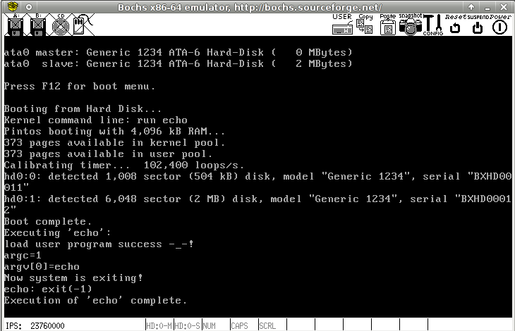

pintos run ‘echo x’ (参数传递)

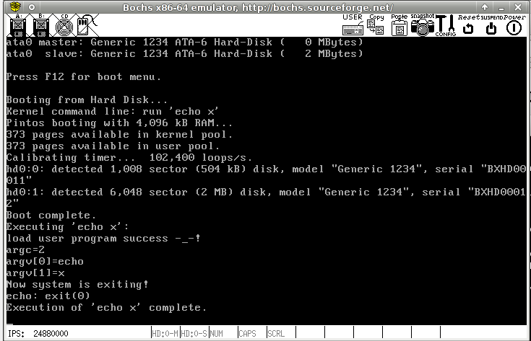

pintos run ‘echo halt’（系统调用）
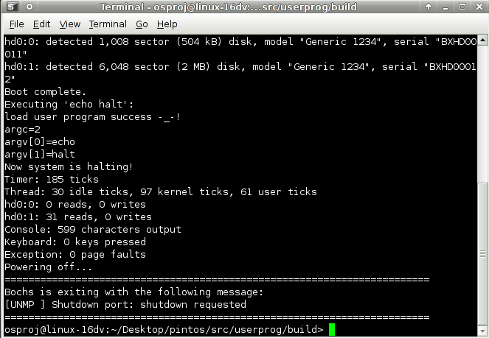
在实验时遇到了错误，却无法找出错在那里，我尝试用gdb进行调试，在userprog/build目录下
pintos --gdb -- run echo
另外打开一个终端，同样进入userprog/build目录下
pintos-gdb kernel.o
target remote localhost: 1234
loadusersymbols echo
b echo.c:main
c
接着输入n进行逐行调试

